CURRICULAM VITAE
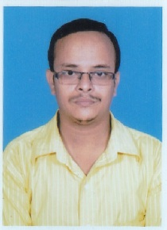

ADDRESS:

Vill – Ramchandrapur

P.O + P.S - Sankrail

Dist. – Howrah, Pin - 711313

Near Ramchandrapur High School.

Mobile No. 7044280813 / 9836683120

Dipankar Chakraborty….

PROFESSIONAL EXPERIENCE:

- Presently Working in M/s. Raunak Coirs Limited (Raunak Mattress, A Group of Company) in Factory : Jalan industrial Complex (Near NH – 6) Howrah, As a Factory Accountant from June 2011 to till now.

PRINCIPLE JOB RESPONSIBILITIES / KEY RESULT AREAS

- MAINTANING OF BOOKS OF ACCOUNTS.
- BANK RECONCILIATION STATEMENT IN TALLY ERP .
- MAKING GST INVOICE & VOUCHER ENTRIES REGARDING DAY TO DAY ACCOUNTS.
- PURCHASE-SALES RECONCILIATION FOR GST RETURN PURPOSE
- MAINTAIN IN PROCESS STOCK STATEMENT OF RAW MATERIALS AND FINISHED GOODS.
- MAKING MIS REPORT AND REPORTING TO H.O ON DAILY BASIS.
- PHYSICAL STOCK RECONCILIATION WITH SYSTEM STOCK ON MONTHLY BASIS.
- MAKING STOCK VALUATION ON MONTHLY BASIS.
- MAKING SALES ORDER, PURCHASE ORDER, PURCHASE BILL, SALE BILL IN TALLY ERP 9.
- MAKING GST E-WAY BILL.

COMPUTER PROFICIENCY:

- Basic Computer course (MS Word, MS Excel, MS Power point etc) completed from
National Council of Vocational Educaton, New Delhi,
- Internet Applications.
- Accounting Packages (TALLY ERP 9).

KEY SKILL:
- TALLY ERP 9 (INVENTORY + ACCOUNTS)
- MICROSOFT EXCEL.
- KNOWLEDGE OF P.TAX ENROLLMENT & PAYMENT.
- KNOWLEDGE OF GST RETURN AND GST RELATED WORK.

REASONS FOR SEEKING NEW JOB
SEEK FOR BETTER CAREER ADVANCEMENT OPPORTUNITIES AND EXPOSURE.

ACADEMIC QUALIFICATION:

QUALIFICATIONS:-

ACADEMIC | - Completed Master Degree (M.Com) from Indira Gandhi National Open University in the year of 2011  - Completed Graduation (B.Com) from University of Calcutta in the year of 2007.  - Completed H.S from W.B.C.H.S.E in the year of 2004.  - Completed Madhyamik from W.B.B.S.E in the year of 2002.

PROFESSIONAL EXPERIENCE:
- Diploma in Financial Accounting from Ramakrishna Mission Shilpamandira Computer Centre, Belur Math, Howrah in 2008.

- GST Training course completed from Ankit Institute of Taxation & Consultancy Services(An e-filling training institute & Law firm)(Trainer – Mr. Shambhu Nath Dhuria – CS , LLB)

AREA OF INTEREST:
INTERNET SURFING, LISTENING MUSIC.

PERSONAL INFORMATION.

Date of Birth : 27TH FEBRUARY’1986.

Nationality : Indian

Sex : Male

Present Address : Vill – Ramchandrap

P.O + P.S - Sankrail

Dist. – Howrah, Pin - 711313

Near Ramchandrapur High School.

Permanent Address : Vill – Ramchandrapur

P.O + P.S - Sankrail

Dist. – Howrah, Pin - 711313

Near Ramchandrapur High School.

Contact No. : 7044280813 / 9836683120 (M),

E-Mail : dip6000.1571@rediffmail.com

Hobby : Listening Music

Language Known : Speak: English, Hindi, Bengali,
Read & Write: English, Hindi, Bengali

Marital Status : Single.

Salary Expectation : Negotiable

Presently working : M/s. Raunak Coirs Limited. (Raunak Group of Company)

Current Salary : Rs. 15,500 /- P.M (In Hand)

Current Designation : Factory Accountant.

I hereby declare that all the information furnished above is true to the best of my knowledge and belief.

Date: 04.02.2019 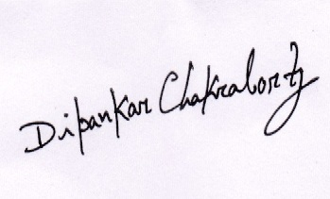
________________________
Place: Sankrail, Howrah. (DIPANKAR CHAKRABORTY)

