# SANDIP KUMAR DAS

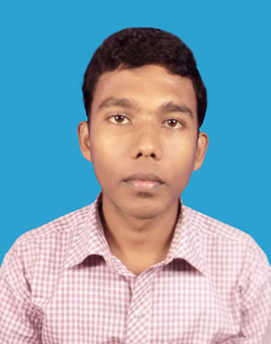

**Paste Your Photo Here**

**Namkhana, South 24 Parganas Mobile : - 8609519975/7074526917 West Bengal, 743357 Email: - d_sandip26@yahoo.com**

**OBJECTIVE**

**I look forward to work with an organization which offers a challenging opportunity to enhancing my knowledge, skills and experience that would allow me to contribute towards achieving the organizational goals to the best of my potential.**

**Education Qualification:**

|  |  |  |  |  |  |
| --- | --- | --- | --- | --- | --- |
| **Examination Pass** | **Name of Board / University** | **Year of**  **Passing** | **Total Marks** | | **% of Marks** |
| MADHYAMIK | W.B.B.S.E. | 2012 | 700 | | 76.42 |
| H.S | W.B.C.H.S.E | 2014 | 500 | | 82.80 |
| B.C.A | SMU | 2017 | | 5800 | 60.6 |

**Extra Qualification:**

* **ADITA from New Namkhana Youth Computer Training Center**.
* **Maintain Account in Tally with GST**

**IT SKILLS**

* **MS Office- Word, Excel, PowerPoint, Outlook & Internet.**
* **Programming knowledge of C, C++, Oracle (SQL & PL/SQL), Basic of Java, VB.Net, HTML & Web Programming.**

**Personal Dossier**

**Father’s Name :** Swapan Kumar Das

**Present Address:**  Vill – Namkhana

P.O+P.S – Namkhana,

Dist – South 24 Parganas

State – West Bengal

Pin – 743357

**Permanent Address:**  DO

**Caste:**  OBC(B)

**Date of Birth:** 01 – 09 – 1996

**Sex:**  Male

**Religion:**  Hinduism

**Nationality:** Indian

**Language Known**

* Bengali – Speak, Read & Write
* English – Speak, Read & Write
* Hindi – Speak & Read

**Behavioral Characteristics**

* Responsibility
* Sincere in attitude
* Commitment to quality and result.

**Strength**

Ability to learn fast, To Take Up any Assignment with Enthusiasm and Adapt to Environment.

**Date:-**

**Place:- Signature**