RESUME
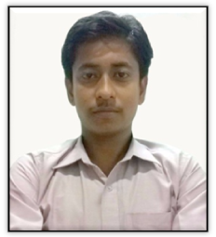

Sagardip Chowdhury

Present Address-
Vill- west kamarthuba
P. O & P. S -Habra, Dist-24 Pgs (N),
Pin-743263
E-Mail – dipsagar.chowdhury@gmail.com
Contact-9126161460

Career Objective.
To join an organization at the entry level where I can exploit my personal skills coupled with the professional skills to achieve Organizational goals .So that I can grow with the organization.

Academic Qualification.
 Pursuing Graduation (B.A GEN) from West Bengal State University.
 Passed H.S from W.B.C.H.S.E in the year 2011
 Passed M.P from W.B.B.S.E in the year 2009

Computer Skills.
6 Months Certificate in Information Technology Application.
6 Months Diploma in Technology application
3 Months Tally ERP9 in All India Vocational & skill Development

Interests.
Games, Music, computers & playing musical instrument.

Personal Details.

I am highly motivated individual, who believes in teamwork, love to take challenges and can do work under pressure.

Fathers name – Sri Satya ranjan Chowdhury
Date of Birth – 06 January1994
Nationality –Indian
Gender –Male
Marital Status –Single
Language Known –English, Hindi, Bengali

Permanent Address-
Vill-West kamarthuba
P. o & P.s-Habra, Dist-24 Pgs (N),
Pin-743263

Work Experience:-

1 Year marketing experience in Command electro security service as a field officer.
2 year sales experience in Orion Edutech Pvt Ltd as a Business Development Manager.
After that I have promoted as a Centre in- Charge on e.f 10th January 2019 to still now.
6 Months Work experience in BPO sector at Agis Group in the year of 2011.

Declaration –

I hereby declare that all the above mention information’s are correct to the best of my acknowledgement and I bear the responsibility for the correctness of the above mentioned particulars

Date – ...,................................ (Signature)
Place –Habra.

