**RESUME**

**Name :**  **SAYANTAN CHAKRABORTY** 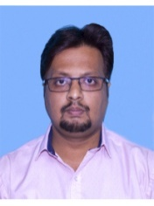

**Address :** ‘Rambabu Apartment’, C-3, 3 Basunagar, P.O + P.S.- Madhyamgram,  
 Dist.North 24-Parganas,State - West Bengal , Pin -700129

**Contact No. :** **(+91) 09062540288 (M) /** **(+91) 07003873146 (M)**

**E-mail :** [**sayantanchakraborty1983@gmail.com**](mailto:sayantanchakraborty1983@gmail.com)

**Career Objective :**

*To associate myself with an organization which will provide a global exposure, challenging tasks and opportunity to apply me in-depth knowledge in the field and develop further with appreciable contribution to the good will of the organization*

**Academic Qualifications:**

|  |  |  |  |  |
| --- | --- | --- | --- | --- |
| **SL.**  **NO.** | **Council** | **Examination** | **Marks (%)** | **Year of passing out** |
| **1.**  **2.**  **3.** | W.B.B.S.E  W.B.C.H.S.E  C.U | **Madhyamik**  **Higher Secondary**  **B.A (General)** | 45.75 %  42.90 %  40.75 % | 2001  2003  2006 |

**WORKING EXPERIENCE :**

**01** year worked as an **ACCOUNTANT** at **DAS AUTO DISTRIBUTOR** , Barasat.  
  **07** years worked as a **OFFICE EXECUTIVE** at M/s.-**TULICHITRA**, Barasat.

**SPECIAL ABILITY (COMPUTER SKILL) :** MS-Office, E-mail, Internet surfing ability, Tally ERP-9 & GST

**Personal Details:**

**Date of Birth : 11th day of August, 1983 (11.08.1983)**

**Father’s Name : Swapan Chakraborty**

**Gender**  : Male

**Hobbies :** Reading Books, Listening Music, Internet surfing, Photography, Travelling, Games & Yoga

**Languages Known :** Bengali, English &Hindi

**Declaration:**

*I hereby declare that the information furnished above is true to best of my knowledge.*

**Date:**

**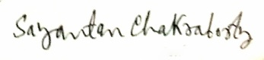  
Place: MADHYAMGRAM**  **Signature**