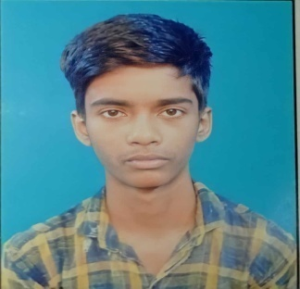 **RESUME**

**NAME -** Sk Firdaus Hossain

**CONTACT NO. -** 8902616714

**EMAIL ID -** [skfirdous492@gmail.com](mailto:skfirdous492@gmail.com)

**Objective :** To work in an organization where I can get the platform to show my talent and skills and sense the company with my best performance to contribute the growth of the company with my best performance and ensure my professional growth.

**Educational Qualification :**

|  |  |  |
| --- | --- | --- |
| **EXAM** | **YEAR OF PASSING** | **UNIVERSITY/BOARD NAME** |
| B.A. General Arts (Appearing) | Waiting | University Of Calcutta |
| H.S | 2021 | W.B.C.H.S.E |
| M.P | 2019 | W.B.B.S.E |

**Professional Qualification :**

1) CCA (Certificate Course In Aplication) From National Institute Of Computer

Education (2019).

2) Tally GST (Waiting for certificate) from tally academy uluberia branch.

**Technical Knowledge :**

Configure dos , Ms word , Ms Excel , Internet Multimedia , Tally , Accountant , Etc…

**Personal Information :**

**Date of Birth :** 16/08/2004

**Father Name :** Sk Lutfar Rahaman

**Address :** Vill+P.O – Khalisani , P.S – Rajapur , Dist – Howrah , Pin – 711307

**Nationality :** Indian

**Date –**

**Place – Signature of the candidate**