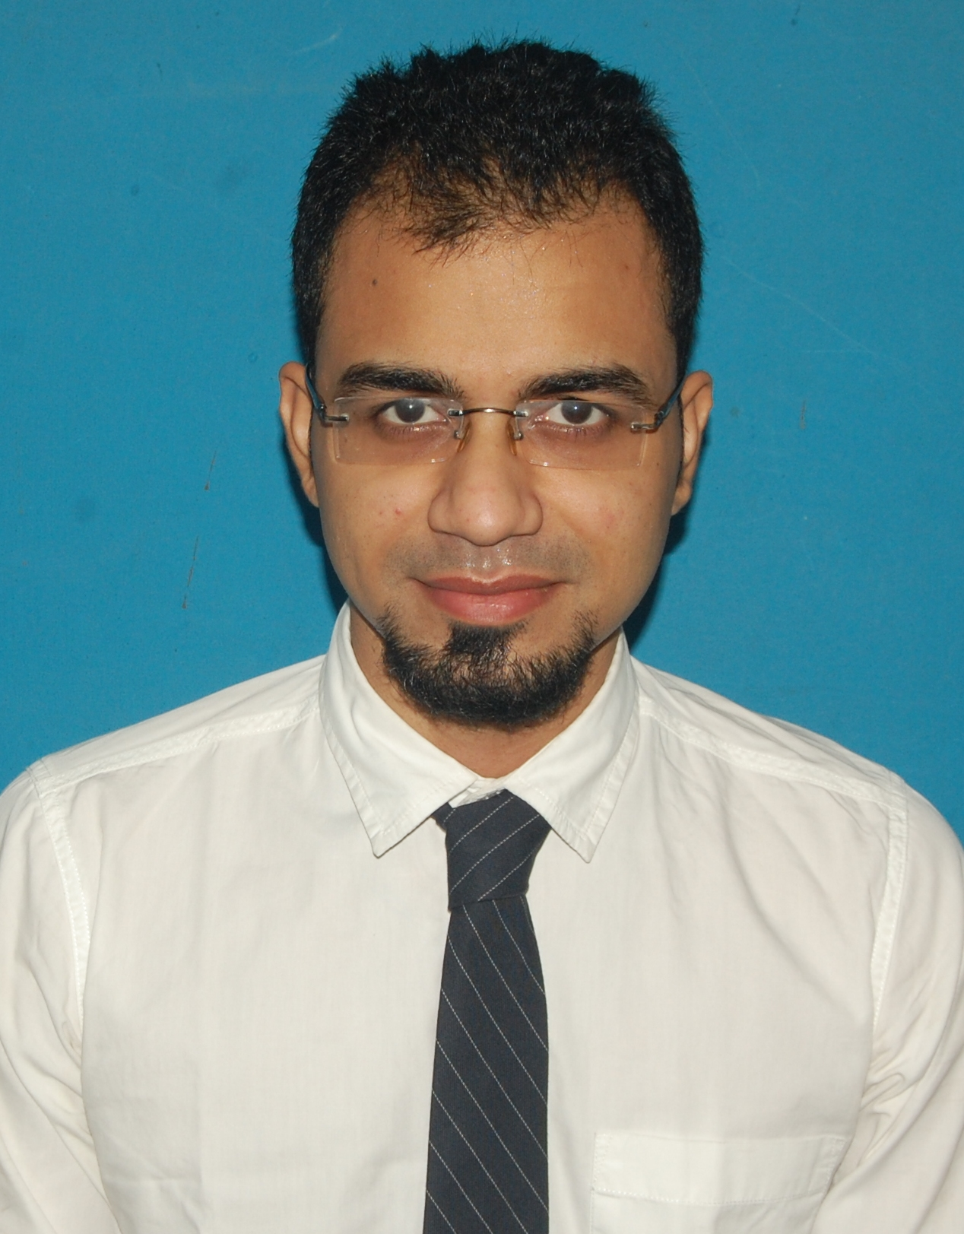
NAME: PINAKPANI BANERJEE
ADDRESS: Flat no-301, Block-B, 33\10 Swami Vivekananda road,
Howrah-711101
E-MAIL ID: pinakpani1992@gmail.com
CONTACT NO: 9903895472/8981706218
-------------------------------------------------------------------------------------------------------------------------------

OBJECTIVE: To join an organization that will recognize and utilize my skills fully and offer me a position requiring innovation and creative ideas where continuous growth and learning are way of life.

WORK EXPERIENCE:
1)D. D. GROUP OF COMPANY LTD
DURATION : SEPTEMBER 2014 – DECEMBER 2014
WORK PLACE : KOLKATA
JOB PROFILE : R. F. ENGINEER

2)M/s Associate Power Construction & Maintenance
Client: - EMC Limited
Duration: -January’15 – March’16
Designation: - Site Engineer
Job Profile: - Substation Maintenance (33/11kv)

3)WBSEDCL
I undertook inspection of operation and maintenance of distribution lines and substations starting from voltage label 33KV – 230V as per laid down guide line from July 2016 to March, 2020.
JOB PROFILE : Inspection & Audit of
a)Operation of 33/11KV substation along with operation of various equipments install at substation
b)Maintenance work of 33 KV substation covering of 33KV power transformer of capacity 3.15/5/6.3/10 MVA &also maintenance of 33 KV line & 11 KV line.

ACADEMIC SKILLS:
NAME OF THE EXAM | NAME OF THE UNIVERSITY\ BOARD | NAME OF  THE SCHOOL/ INSTITUTION | YEAR OF PASSING | MARKS
B. TECH  ELECTRICAL  ENGINEERING | WEST BENGAL  UNIVERSITY OF  TECHNOLOGY | MODERN INSTITUTE OF  ENGINEERING  AND  TECHNOLOGY | 2014 | 7.63  (CGPA)
HIGHER  SECONDARY | W.B.C.H.S.E | HOWRAH VIVEKANANDA  INSTITUTION | 2010 | 65%
SECONDARY | W.B.B.S.E | HOWRAH  VIVEKANANDA  INSTITUTION | 2008 | 80%

TRAINING/PROJECT:

- ORGANISATION : Calcutta Electric Supply Corporation(CESC)
- DESCRIPTION :Training on Electrical Substation

- ORGANISATION : Railway Workshop Training(TRS)
- DESCRIPTION :Training on Railways Maintenance

PERSONAL SKILLS:

- Hardworking and flexible
- Fast adaptability
- Good interaction skills

SUBJECT ENJOYED MOST DURING COURSE WORK:

- DC Machines
- Power System

SOFTWARE SKILLS:

- Certificate On Java7 From Globsyn
- Microsoft Office

ACHIEVEMENTS:

- Achieved district level certificate for volley ball.
- Achieved many school level certificates for football.

EXTRACURRICULAR ACTIVITIES:

- Lead the college and school football team.
- Participating in football and volley ball tournaments.

PERSONAL DETAILS:

FATHER’S NAME : Pradip Kumar Banerjee
MOTHERS’S NAME : Suparna Banerjee
SEX : Male
NATIONALITY : Indian
DATE OF BIRTH : 11\08\1992
LANGUAGES KNOWN : Bengali, Hindi and English.
HOBBIES : Sports and games (football and volley ball), listening music.

DECLARATION:
I do hereby declare that the above information is true to the best of my knowledge.
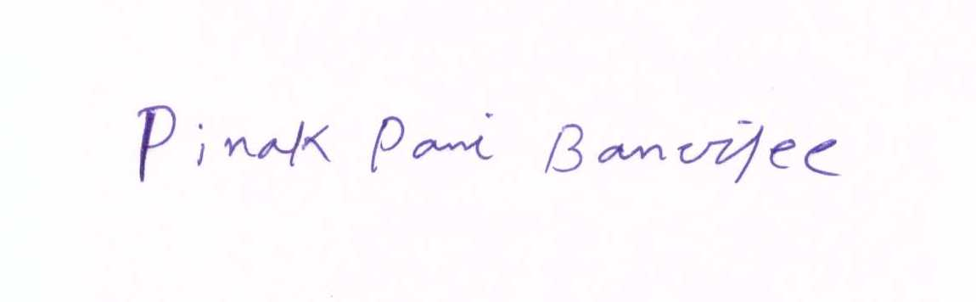

Date: _________________
Signature

