Working experiences both in IT and Non-IT sectors as Commercial and Finance Executive.
Address: 14, Iswar Biswas Lane, P.O.- Nimta, Kolkata - 700 049.
Contact Number: 09062480743 / 07980203348
Email ID: debabrata1979@yahoo.com / kumardebu20065@gmail.com
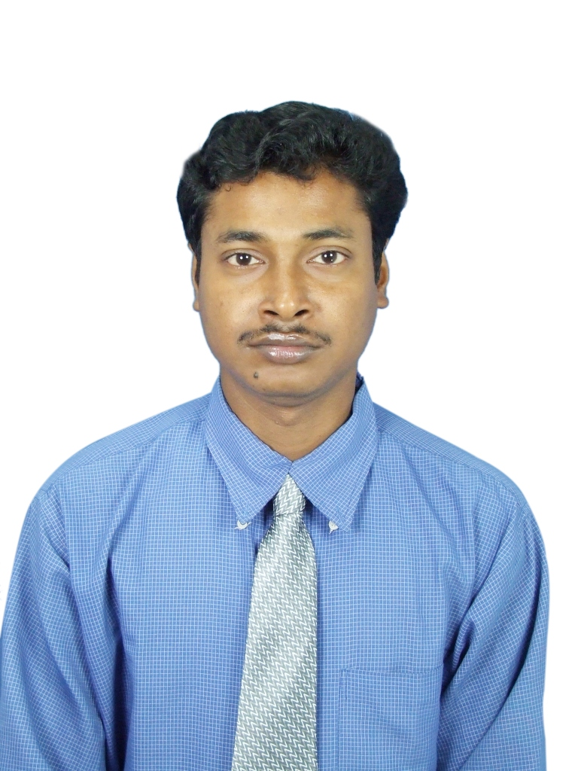

DEBABRATA MITRA
Objective: Be a part of a dynamic organization to utilize my resources and capabilities to the fullest extent.

General information:

- Date of Birth: October 29, 1979.
- Language known: Bengali, English, and Hindi.

Working Experiences with job profiles:
Working as Billing Executive in RAHEE INFRATECH LTD. (ISO 9001-2008)(An Engineering Co.), Howrah  From January 2013 To till date. | Job Profile:  - Performing as Commercial and Logistic executive.  - Prepare of GST Invoice with ERP and Excel.  - Prepare invoice of "Flash Butt Welding".  - Prepare invoice of "Bridge Girder".  - Prepare "Price Variation Calculation” & “Price Variation Invoice”.  - Preparing Letter of Credit documents for Bill of Exchange and sent to Bank for payment.  - Maintain daily stock & DSA report with material value realization by Excel (Data collect from ERP), Bill entry and passing through ERP.  - Collect online waybill and fill up them for dispatch job.  - Prepare work order with ERP & register maintain for this job.  - Handling entire documentation involved from finalization of order to completion of order.  - Maintain outstanding list of Customer by using of ERP & payment collection from vendor.  - Prepare Bank Guarantee.  - Visit the all railway division and others client for collect the payment & other official job.
Worked as part time Accountant  in Nirmal Hardware and Compotech Enterprise, Kolkata  From October 2016 To till date.  Worked as Commercial Executive in ARCVAC FORGECAST LTD. (A customized speciality steel producer with ISO 9001-4000 Cert.), Kolkata  From January 2010 To December 2012.  Worked as Accounts executive in VIDYUT ENTERPRISES.  (An Electrical Contractor), Kolkata  From November 2006 To December 2009. | Job Profile:  - Performing as Commercial executive.  - Accounting and inventory entry in tally.  Job Profile:  - Performing as Commercial executive.  - Making of Tax Invoice with ERP.  - Making Job work invoice.  - Prepare ARE 1 for “SEZ” and doing all excise work related to this job.  - Maintain daily stock & DSA report with material value realization by Excel (Data collect from ERP), Bill entry and passing through ERP. Supervising of loading & unloading the materials.  - Collect online waybill and fill up them for dispatch job.  Handling store cash (vendor payment, labour wages payment)  Job Profile:  - Performing as general accountant  - Handling the entire job regarding Cash (vendor payment, worker wages payment, staff salary payment, site staff & labour payment) Bank and Service Tax.  - Maintain all register & input data in computer with Tally Accounting Software.  - Make primary Trial Balance and Profit & Loss of Company by Computer and handling other Accounting Works.
Worked as Accountant in RECON CASTINGS PVT. LTD.  (A Steel Foundry Company), Kolkata  From August 2002 To October 2006. | Job Profile:  - Performing as general accountant)  - Handling the entire job regarding Cash (handling petty cash, staff salary payment) and Bank.  - Maintain all register & input data in computer with Tally & Ex- Next Generation Accounting Software.  - Make primary Trial Balance and Profit & Loss of Company by Computer and handling other Accounting Works.  - Handling Dispatch Department & maintain register for kept record of all dispatch materials.
Worked as Computer Faculty  in CMC- Belghoria (a computer learning centre), Kolkata  From July 2000 To July 2002. | Job Profile:  - Teaching of MS Office & F.A. Courses.

Educational Qualifications:

- Passed Madhyamik Pariksha (10th class) under West Bengal Board of Secondary Education from Belghoria High School, Kolkata in 1996.
- Passed Higher Secondary Examination (12th class) under West Bengal Council of Higher Secondary Education from Belghoria High School, Kolkata in 1998.
- Passed Bachelor of Commerce (B.Com) under University of Calcutta from City College of Commerce (Mirzapur City), Kolkata in 2001.

Professional Qualifications:

- Completed 6 month Computer Basic & Accounting packages, from “COMPUTER & TECHNOLOGY” (CAT), Belghoria, Kolkata-56 in the year 2000.
- Completed a complete Accounting Course from “INSTITUTE OF COMPUTER ACCOUNTS” (ICA)
The Modules Completed are: -
- MS Office & Internet
- Advance Accounts
- Income Tax, Sales Tax, Service Tax, VAT
- Tally 9 & ACE, E-Tax (Account Software)
- Central Excise
- ROC, Banking, Labour Law
- Effective Communication & Personality Development Programme.

Computer Knowledge: DOS, Windows, MS-Word, MS-Excel, MS-PowerPoint, Data Base Fox-pro, FA Package (Tally 5.4, 6.3, 7.2, 9.1, ACE, Ex-Next Generation, Accord, Fact, Analyst, E-Tax), ERP Software and Email & Internet & ERP.

Strength: Honesty and hardworking with the zeal of learning quickly to enhance my performance.

---------------------------------------
[DEBABRATA MITRA]

Date:
Place:

