CURRICULUM VITAE

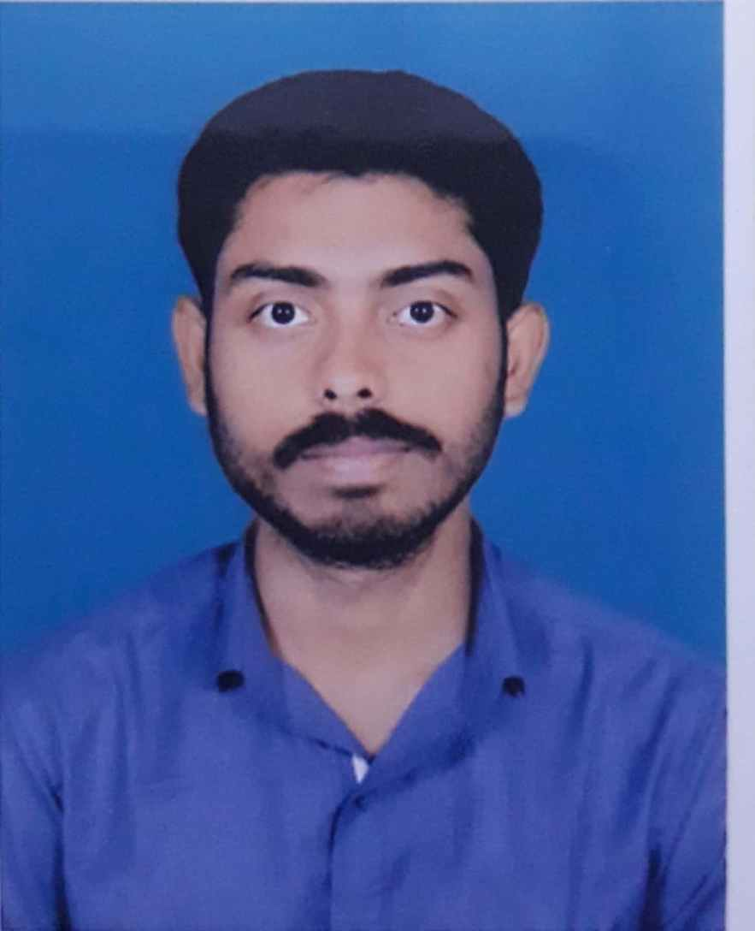

SUBHAM DEY MOHURI

BADU 2ND MAIN ROAD, BARASAT, KOLKATA-128

CONTACT NO- 9836903294

EMAIL ID- [DEYMOHURISUBHAM@GMAIL.COM](mailto:DEYMOHURISUBHAM@GMAIL.COM)

EDUCATIONAL QUALIFICATIONS

|  |  |  |  |
| --- | --- | --- | --- |
| EDUCATION | SCHOOL/COLLEGE/UNIVERSITY | PASSING YEAR | MARKS |
| M.A IN ENGLISH LITERATURE | RABINDRA BHARATI UNIVERSITY | 2017 | 54.25 |
| B.A IN ENGLISH LITERATURE | WEST BENGAL STATE UNIVERSITY | 2014 | 49.25 |
| H.S | GUSTIA.K.N.HIGH SCHOOL | 2011 | 61.66 |
| MADHYAMIK | GUSTIA. K.N HIGH SCHOOL | 2009 | 76.66 |

PROFICIENT IN - MS WORD, MS EXCEL, TALLY ( TALLY ACADEMY BARASAT), TYPING, DATA ENTRY

PREVIOUS EXPERIENCE- JUNIOR CONTENT RESEARCHER FOR 3 MONTHS

PERSONAL DETAILS-

|  |  |
| --- | --- |
| NAME | SUBHAM DEY MOHURI |
| DOB | 02/10/1993 |
| FATHER’S NAME | GANESH DEY MOHURI |
| OCCUPATION | SERVICE |
| LANGUAGE KNOWN | ENGLISH,HINDI,BENGALI |
| HOBBIES | SINGING,WRITING POETRY,MIMICING |