RÉSUMÉ 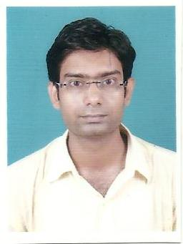

Sabyasachi Majumder
Email: sabyasachi.majumder@gmail.com
Contact: +91-9143198297/6289199503

OBJECTIVE

In pursuit of a career in the industry that recognize & appreciates
my technical acumen & ability.

EDUCATIONAL QUALIFICATION

- B-Tech (2010-2013) in the Stream of Computer Science and Engineering,Future Institute of Engineering & Management,Kolkata with DGPA of 7.11 (63.6%).
- Diploma (2006-2010) in the Stream Of Computer Science and Technology,Dumkal Polytechnic,Dumkal with 69.2%.

- Higher secondary (2003-2006) from Praffullanagar Vidyamandir, with an aggregate of 45.9%.

- Secondary (2003) from Habra High School, Habra with an aggregate of 62%.

KEY STRENGTHS

- Positive attitude and good problem solving skill.
- Flexible, Dedicated and Hardworking.
- Self Confident and Self Motivation.
- Adaptable to any Environmental Situation.
- Co-operative in Team.
- Helping Nature.

EXPERIENCE :

- Working with HCL Infosystem Limited as Coordinator for Two years and Three years Computer Science Faculty in George school of competitive exam(GSCE),A Unit Of George Telegraph. One year & Two month's worked As Centre Manager Cum Course Counsellor in IBS Institution.Working in Organization Sector Last 5 Years.

EXTRA QUALIFICATION :

- Diploma in Computer Hardware Maintenance

INTERESTED IN

- Playing & Watching Cricket, Badminton.

PERSONAL DETAILS

Name : Sabyasachi Majumder
Fathers name : Late Sushil Kr. Majumder
Gender : Male.
Date of Birth : 29th December 1987.
Address : C/o Dipak Majumdar,47/A Rabindrapally,Netaji Road
Near Pujari Sangha Club, Barrackpore,
Kolkata-700122
N:24 Pgs
Nationality : Indian.
Known Languages : Bengali, Hindi,English.

DECLARATION

I hereby declare that the information furnished above are true and correct to the best of my knowledge.

Place: Yours Sincerely
Date:

