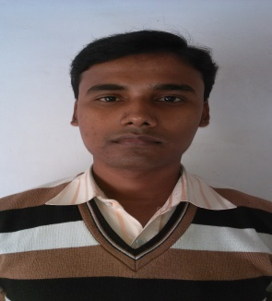BIO-DATA

PANKAJ CHAKRABORTY

Email ID: pankajborty2015@gmail.com

**Mobile No : 8240676475/9073140315**

Personal Information

**Date of Birth :- 16th SEPTEMBER. 1985.**

## Father Name :-SRI. JATISH CHAKRABORTY.

## [ OCCUPATION: - BUSINESS]

# Mother Name:-SMT.MAYA CHAKRABORTY.

# [OCCUPATION:-HOUSEWIFE]

# Nationality :-INDIAN. Religion :-HINDU.

**Sex :-MALE.**

**Permanent address :-VILL:- DURGANAGAR, P.O+P.S:- RANIR BAZAR,**

**AGARTALA, TRIPURA (W). PIN – 799035.**

**Present address :- PANKAJ CHAKRABORTY,C/O – KAMAL KANTI MUKHERJEE,**

**WEST HRIDAYPUR, MAULANA AJAD ROAD, NEAR 3No**

**WATER PAMP,**  **KOLKATA – 700127.**

**.**

|  |  |  |
| --- | --- | --- |
| **Speak** | **HINDI** | **BENGALI.** |
| **Read** | **ENGLISH** | **BENGALI.** |
| **Write** | **ENGLISH** | **BENGALI** |

**Languagesknown :-**

Educational Qualification

* **Passed (Xth) Tripura Board Of Secondary Board in the year 2004.**
* **Passed (H.S+2) Examination (Commerce) of Tripura Higher Secondary Board in the year 2006.**
* **Passed B. Com. Examination under TripuraUniversity in the year 2010.**

Professional Educational Qualification

* **Complete for MBA Finance [ Himalayan University ] in Arunachal Pradesh.**
* **Study for CA [ The Institute of Chartered Accountants of india ] in Kolkata.**

Others Qualification

* **Office Package & Financial Accounting [ Tally - 7.2, Tally -9 & Tally ERP 9 ]**

Work Experience

xperience

* **02 (Two) years experience Assistant Accountant as a Chartered Accountant Firm “SaikatDatta& Associates” at Agartala.**
* **October, 2013 to August 2015 Now experience as a Assistant Accountant in M/s M.P.KHAITAN, Construction Engineers at Agartala.**
* **September, 2015 to January 2016 Now experience as a Accountant in Ayushman InfoTech Pvt. Ltd. Govt. Service Provide Company at Agartala.**
* **Current Employee as a Accountant in InfoTech Company at Kolkata.**

**Date:-31/08/2020**

**Place:-Hridaypur.**

**PankajChakraborty.**

**(Signature of the applicant)**

.